Computing Coursework 2 – Solving engineering problems with a programming language
Name: Oliver Chadwick
Student ID: 20693230

Add the relevant parts to the various sections below. Once complete, add this document to the .git repository and submit it together with your code, text files and functions.

Task 1 – read temperature data, plot, and write to a log file
- Include a photograph of the implementation here.

- Include the plot as an image here.
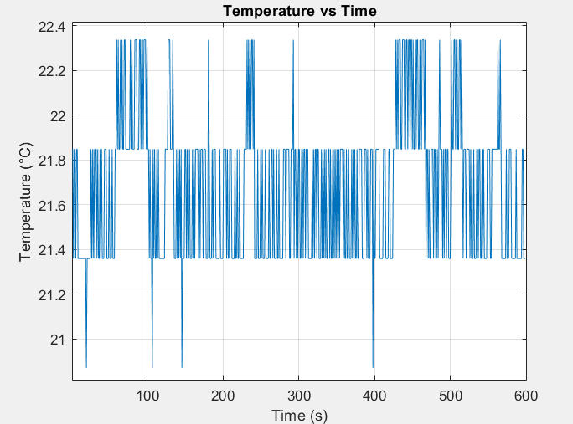

TASK 2 – LED temperature monitoring device implementation
- Include a photograph of the implementation here.

- Include your initial flowchart here.

- Include the plot as an image here.

- Include your final flowchart here.

TASK 3 – ALGORITHMS – TEMPERATURE PREDICTION
- Include your initial flowchart here.

Task 4 – reflective statement
- Add your reflective statement here.

